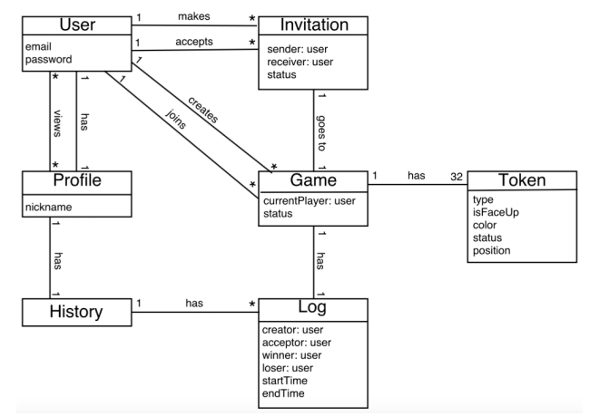

User

*Email* - Inputted by the user as they register, this is a unique email used to register the user.

*Password* - Inputted by the user as they register, this is a personal string they use to login in order to ensure account security and exclusivity.

Invitation

*Sender : User* - The user that sent the invitation.

*Receiver : User* - The user to whom the invitation is sent.

*Status -* Whether the invitation was accepted or rejected.

Profile

*Nickname* - Inputted by the user as they register, this is a unique shorthand way of recognizing some given user.

History

*There are no attributes for history, as a history is simply a collection of logs.*

Log  
*Creator : User -* The user who created the game. This is also the user who makes the first move.

*Acceptor : User -* The user who accepted the game invitation for that game.

*Winner : User -* After the game has ended, this is the user who won the game.

*Loser : User -* After the game has ended, this is the user who lost the game.

*Start Time -* The time that the game was created (i.e.; the time the invitation was accepted).

*End Time -* The time that the game ended.

Game

*Current Player : User* - This is a reference to the player in some active game who is to make the next move.

*Status -* Whether the game is currently active or inactive (once it becomes inactive, end time/winner/loser are recorded and the log becomes final).

Token

*Type* - This describes the type of piece of the token, which can be any one of the following - General, Advisor, Elephant, Chariot, Horse, Cannon, or Soldier.

*isFaceUp* - This is a True or False value used to determine whether or not the piece is face up.

*Color* - Any given token can have 1 of 2 colors - *black* or *red*.

*Status* - This determines whether or not some given token has been removed from play - meaning that tokens can be *active* or *inactive*.

*Position* - This is the position of the piece on the game board, given as an index. (ex [0, 0])